Pöttinger: FLEXCARE with Profiline comfort control system
Flexibility meets precision

As a specialist in arable farming machinery, Pöttinger is always up to speed with optimising production methods in agriculture. The mechanical crop care range includes the FLEXCARE row crop cultivator that offers full flexibility working in a variety of crops. FLEXCARE can now be equipped with the Profiline comfort control system as an option. The Profiline comfort control system is available on all machines with up to 16 rows.

Profiline comfort control system for precision operation
With the Profiline comfort control system machines can be operated directly either using an ISOBUS tractor terminal or other compatible control terminals. Each function is carried out immediately by pressing a button or the touchscreen.
The hydraulic oil supply is regulated by a load sensing system. This means that only the power that is actually needed is requested from the tractor hydraulics. This saves energy and increases the productivity of the tractor.

Maximum convenience
Each hoe element has a double-acting hydraulic cylinder so the hoe can be raised by tapping on the display, or controlled automatically by GPS signals at the headland and in field corners. This means less fatigue for the driver, who can focus on the working results of the row crop cultivator.

Profiline comfort control system with Section Control
The optional Profiline comfort control system on the FLEXCARE can lift all the hoes at the same time at the end of the field, and allows each hoe element to be controlled individually if the field tapers into a corner. The weeding tools are raised and lowered with pinpoint accuracy using ISOBUS. This happens automatically when crossing the crop lanes. Ultimately, this system protects the crop, especially in wedge-shaped corners, overlaps and along field boundaries.

Photo preview:
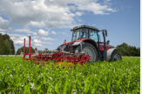 | 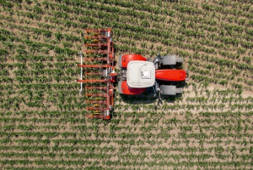 | 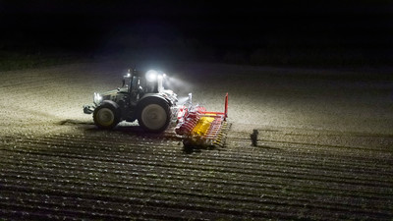
FLEXCARE V 6200  with precision control | FLEXCARE V 6200  does a great job in wedge-shaped fields | FLEXCARE V 6200 equipped for flexible operation
https://www.poettinger.at/de_at/newsroom/pressebild/105275 | https://www.poettinger.at/de_at/newsroom/pressebild/105274 | https://www.poettinger.at/de_at/newsroom/pressebild/15341

More printer-optimised photos: http://www.poettinger.at/presse

